



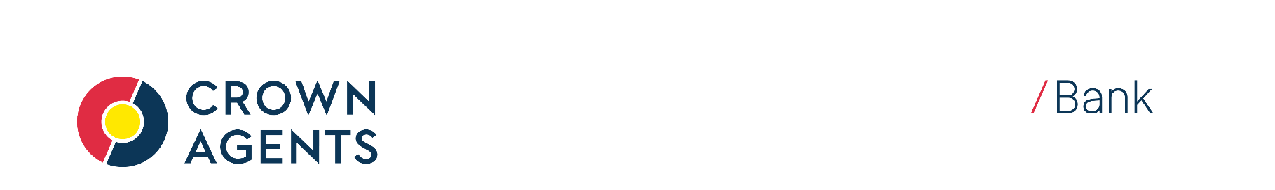
Payment Mandate Kuwait for payment in GBP

Application for payment by direct deposit into a bank account

PLEASE INDICATE WHETHER THIS IS A NEW INSTRUCTION OR AN AMENDMENT TO EXISTING ACCOUNT DETAILS

NEW [] |  |  | AMENDMENT []

- Fill in the form in CAPITAL LETTERS. Complete account number from the left & include any dashes (-).
- Complete Parts 1 and 2. Your bank will help you if you are not sure of the branch/bank codes.
- Sign Part 3.
- If you have nominated a cheque account, please attach a cheque, clearly marked ‘CANCELLED’, to this form.

PART 1
Your Name:____________________________________________________________________
Forename(s) Surname
Your Address:___________________________________________________________________
____________________________________________________________________

Your Reference Number if you have one: |  |  |  |  |  |  |  |  |  |  |  |  |  |  |  |  |  | FI2/

PART 2
Name of Bank or Financial Institution:_______________________________________________

Name of Branch of Bank or Financial Institution:_______________________________________

Full Address of Bank or Financial Institution:__________________________________________
_______________________________________________________________________________

Bank BIC (SWIFT) Code: |  |  |  |  |  |  |  |  |  |  |  |  |  |  |  |  |  |  |  |  |  |  |  |  |  |  | This can be obtained from your bank
Account Number:
The Account is in the Name(s) of:___________________________________________________

PART 3 Please sign below
Please pay my pension payments by direct deposit to the account noted above:

Signature: Date:

FOR OFFICE USE ONLY
Created (): |  |  | Amended (): |  |  |  |  |  |  |  |  |  |  |  |  |  |  |  |  |  |  |  |  | Inputter: |  |  |  |  |  |  |  |  |  |  |  |  |  |  | Date:
Other (specify): |  |  |  |  |  |  |  |  |  |  |  |  |  |  |  |  |  |  |  |  |  |  |  | Authoriser: |  |  |  |  |  |  |  |  |  |  |  |  |  |  | Date:

